21 March 2024

National, state and territory population, September 2023
Australia’s population was 26.8 million at 30 September 2023. This was 2.5 per cent higher than a year earlier, the highest level of growth since the 1950s.
Growth was driven by a net inflow of 549,000 overseas migrants over the year to September 2023. The historically large inflow of overseas migrants continues to reflect a catch-up following pandemic-era border restrictions. Elevated NOM has been driven by arrivals of temporary migrants, particularly students, while departures remain low due to the relatively recent arrival of many temporary migrants.
Natural increase (births minus deaths) remained low, falling to 111,000 over the year to September 2023. This was a decrease of 4.0 per cent from September 2022. Lower births drove this decline, partially offset by lower deaths.
Western Australia’s population grew faster than any other jurisdiction over the year to September 2023 at 3.3 per cent, followed by Victoria (2.9 per cent) and Queensland (2.7 per cent). Tasmania (0.3 per cent) and Northern Territory (0.7 per cent) were the slowest growing jurisdictions.

National population growth
Australia’s population grew by 660,000 people over the year to September 2023. The annual population growth rate of 2.5 per cent increased slightly from the June quarter (2.4 per cent), reaching the highest level since the 1950s. The population grew by 173,000 people or 0.6 per cent in the September 2023 quarter. This was driven by Net Overseas Migration (NOM) as students arrived for the second semester, while natural increase remained relatively low (Chart 1).
NOM (Chart 2) reached a new high of 549,000 over the year to September 2023. NOM in the September 2023 quarter was 145,000, the second highest on record. NOM is seasonal, with students driving higher NOM in the March and September quarters.
NOM for 2022-23 was revised up to 528,000, from 518,000. The latest four quarters of NOM are preliminary and subject to future ABS revisions. The September quarter NOM will be finalised in March 2025.
Natural increase over the year to September 2023 was 111,000, a fall of 5,000 (4.0 per cent) compared to September 2022. The fall was driven by lower births, with 295,000 births over the year to September 2023, a decrease of 3.6 per cent. This was offset by annual deaths (184,000) decreasing 3.4 per cent from the previous year. Fertility and mortality are detailed in Charts 4 and 5.

Quarterly national population growth and components
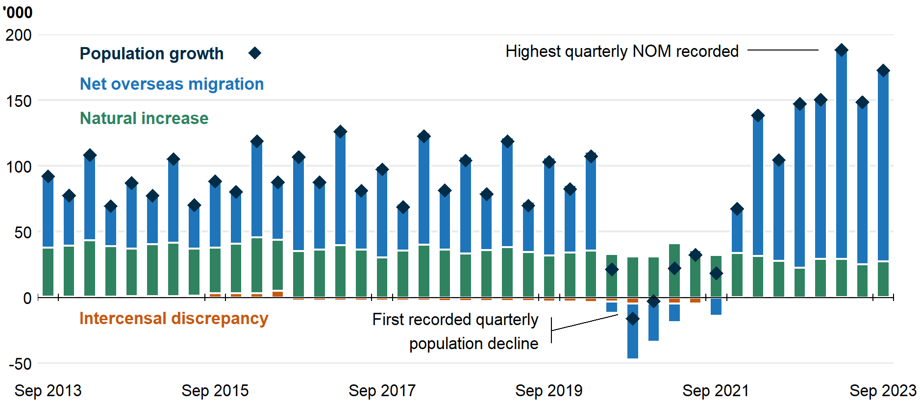
Overseas migration  NOM was the main driver of population growth, adding 549,000 people over the year to September 2023, including 145,000 in the September quarter.  Elevated NOM has been driven by arrivals of temporary migrants, particularly students, reflecting a catch-up from low or negative NOM during the pandemic. Departures remain low due to the relatively recent arrival of many temporary migrants.  Overseas migration, year ending  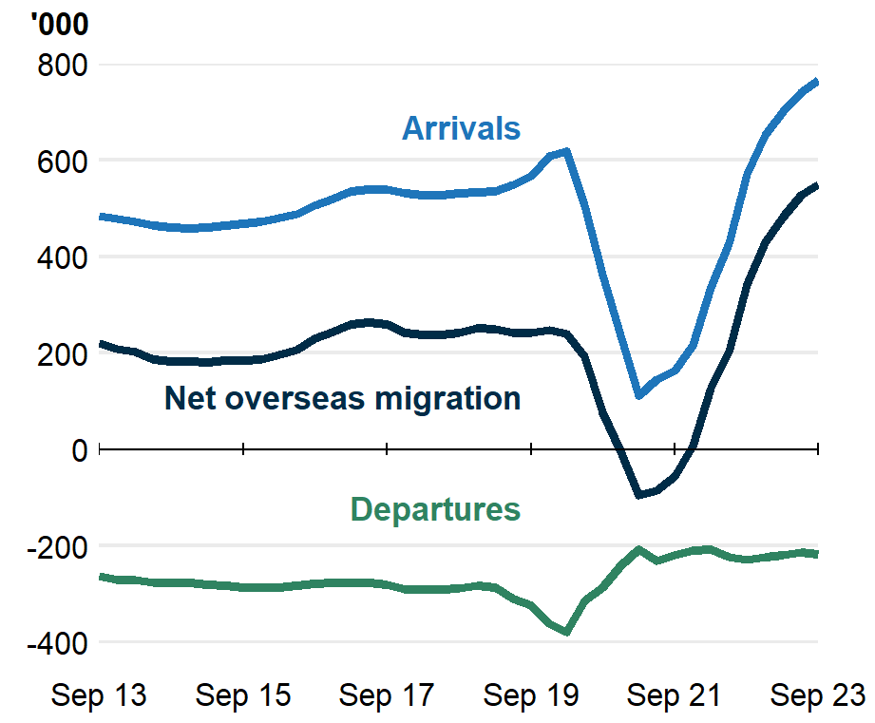 | Internal migration  Interstate migration is below pre-pandemic levels, with interstate moves over the year to September 2023 (379,000) 21 per cent below September 2019.  There was a net flow of 27,000 residents moving from capital cities to regions over the year to September 2023, a decline from highs seen during the pandemic. This was driven by increased arrivals to the capitals, which previously fell due to pandemic lockdowns.  Interstate migration, year ending  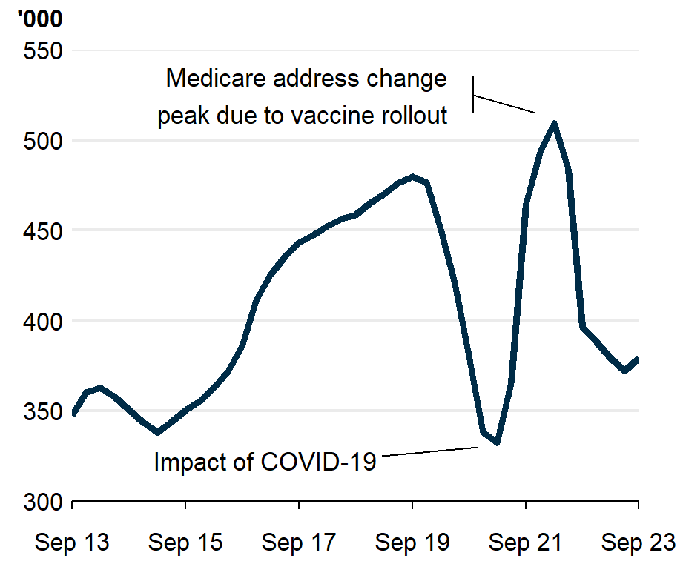
Fertility  The total fertility rate is at a record low of 1.58 in 2022-23. However, fertility has fluctuated since the pandemic. The ‘COVID-19 baby bump’ (1.66 in 2020-21 and 1.69 in 2021-22) brought the first fertility increases since 2008-09. This then fell away sharply in in 2022-23.  September 2023 quarter births suggests fertility may remain low in 2023-24, although it is too early to say.  Total fertility rate, births per woman  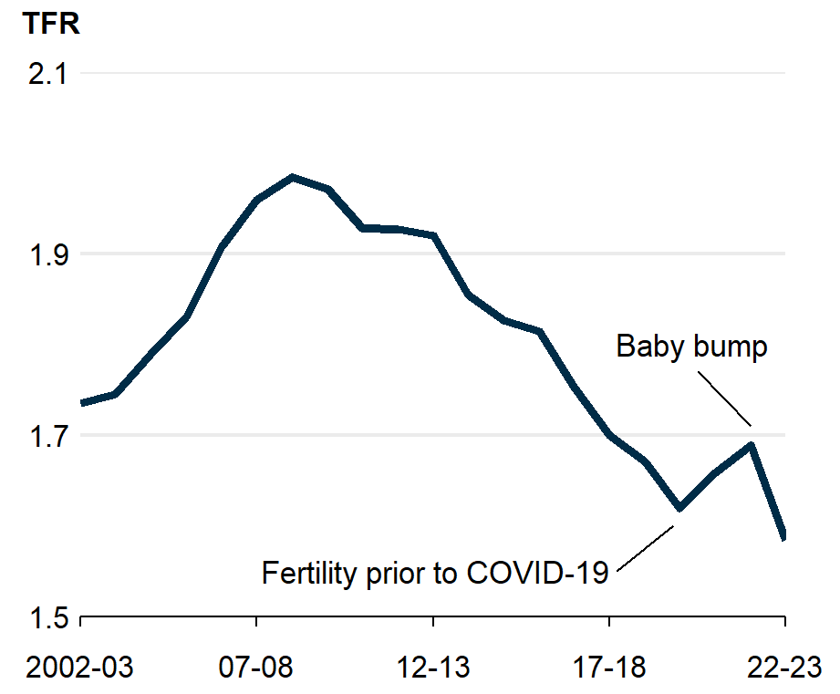 | Mortality  Life expectancy in Australia decreased due to the impact of COVID-19. The standardised death rate, which controls for age structure, was at a low of 4.9 in 2020-21 as pandemic restrictions lowered deaths from viruses like the flu. The rate has increased to 5.3 by 2022-23 as COVID-19 became more widespread.  September 2023 quarter deaths are down 11 per cent from one year earlier.  Standardised death rate, deaths per 1,000  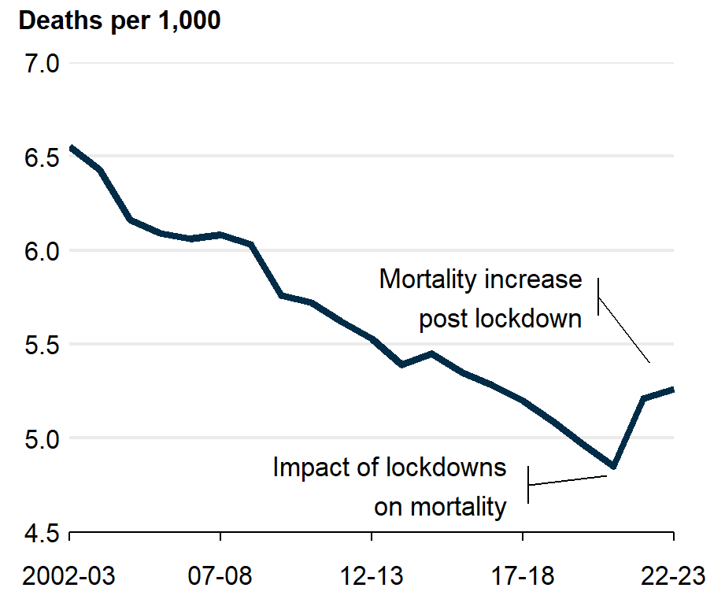
State and territory population growth | National State Other states

New South Wales
Despite a large net inflow of overseas migrants (186,000), population growth in NSW (2.3 per cent) is below the national average due to the net outflow of residents to other states and territories (33,000), particularly to Queensland.

Victoria
Population growth in Victoria has recovered (to 2.9 per cent) after the large population decline recorded during the pandemic. The recovery was driven by overseas migration with Victoria attracting a disproportionally large share (29 per cent) of NOM.

Queensland
Unlike other states, Queensland’s strong population growth (2.7 per cent) is driven not just by overseas migration (88,000), but also by relatively large contributions from interstate migration (33,000) and natural increase (23,000).

South Australia
South Australia’s population is growing at about the fastest rate (1.7 per cent) since 1981 (when the series began), with the growth predominantly from NOM (29,000). Net interstate migration (NIM), has returned to its pre-pandemic trend of an outflow (-1,000).

Western Australia
Currently the fastest growing state (3.3 per cent), Western Australia has population growth comparable to levels seen during the mining investment boom around 2010. Both NOM (68,000) and NIM (11,000) are driving the rapid population growth as mining expands.

Tasmania
Tasmania has fallen to be the slowest growing state in September 2023 (0.3 per cent) from the second fastest in September 2019 (1.8 per cent). NIM has recently returned to a net outflow from Tasmania (-3,100), driving the fall.

Northern Territory
The Northern Territory’s population growth (0.7 per cent) has been positive since December 2019, after 6 quarters of population decline. The NT’s recent growth has been driven by NOM (3,200) and natural increase (2,200), with NIM (-3,600) lowering growth.

Australian Capital Territory
The ACT’s population growth (2.1 per cent) has recently fallen below the national average due to a small NIM outflow (-1,800). Historically, the ACT has grown faster than national average since 2014, due to strong NIM inflows.

Population and population growth
State | ERP | ERP Increase | ERP Increase | Natural Increase | NIM | NOM
 | 30 Sept 2023 | Since Sept 2022 | Annual % | Annual | Annual | Annual
NSW | 8,395,000 | 186,000 | 2.3 | 33,000 | -33,200 | 186,000
VIC | 6,865,000 | 193,000 | 2.9 | 32,000 | -1,100 | 162,000
QLD | 5,496,000 | 144,000 | 2.7 | 23,000 | 33,000 | 88,000
SA | 1,860,000 | 31,000 | 1.7 | 3,200 | -1,000 | 29,000
WA | 2,906,000 | 94,000 | 3.3 | 15,000 | 11,000 | 68,000
TAS | 573,000 | 1,600 | 0.3 | 300 | -3,100 | 4,400
NT | 252,000 | 1,800 | 0.7 | 2,200 | -3,600 | 3,200
ACT | 469,000 | 9,600 | 2.1 | 2,600 | -1,800 | 8,800
Australia* | 26,822,000 | 660,000 | 2.5 | 111,000 | NA | 549,000
* Includes other territories comprising Jervis Bay Territory, Christmas Island, the Cocos (Keeling) Islands and Norfolk Island.

Upcoming population releases
Release | Release date
Overseas migration, September 2023 | 21/03/2024
Regional population, 2022-23 | 26/03/2024
Provisional mortality, Jan – Dec 2023 | 26/03/2024
National, state and territory population, December 2023 | 13/06/2024

Notes
Further detail is available from the Australian Bureau of Statistics

